## C:\rpi devel\QB\src\QB\images\wbl.jpg

**Smart Scoreboard**

The Screen

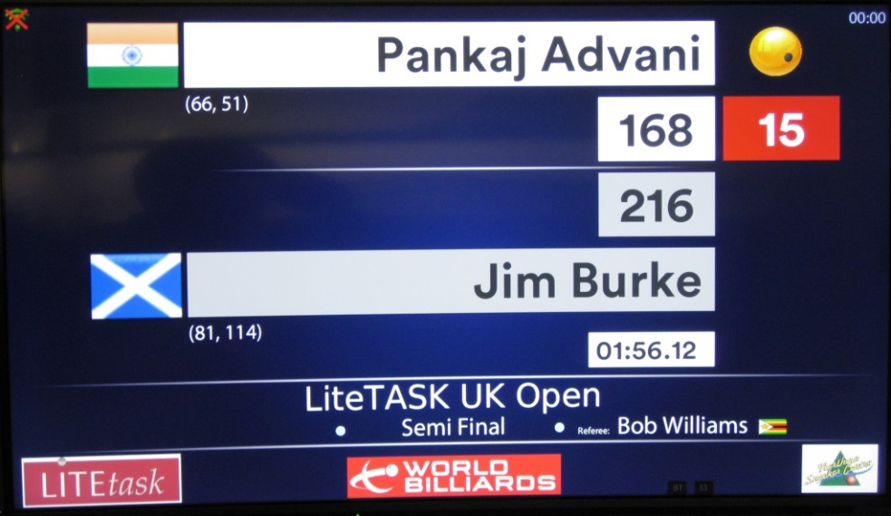

The Zapper

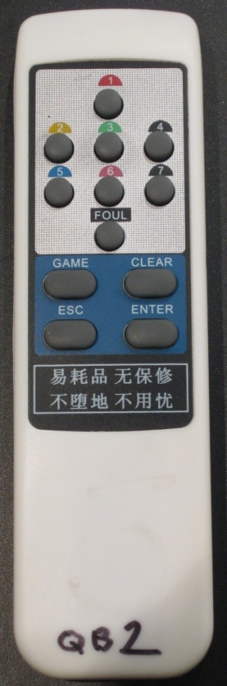

My Notes

**Normal Operation**

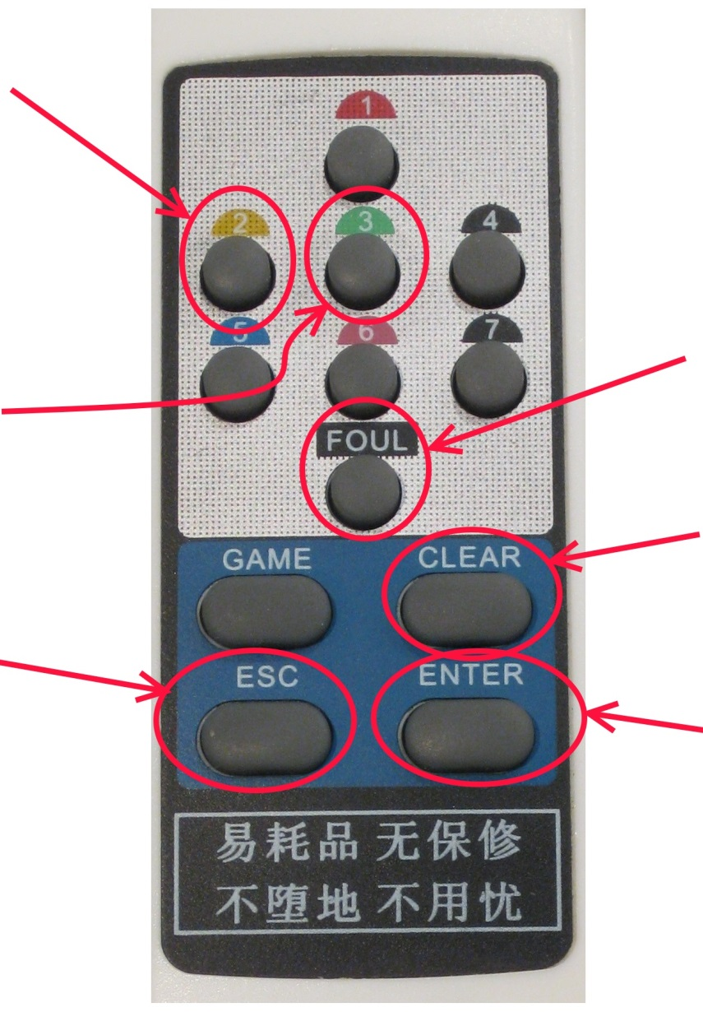

**Enter MENU mode**(see next page)

**END Break  
(ie. next player)**

**FOUL (2 pts)**

**PAUSE or RESUME Match**

**THREE points**

**TWO points**

Note that the following buttons are not used :- 1, 4, 5, 6, 7, GAME.

**Menu Operation**

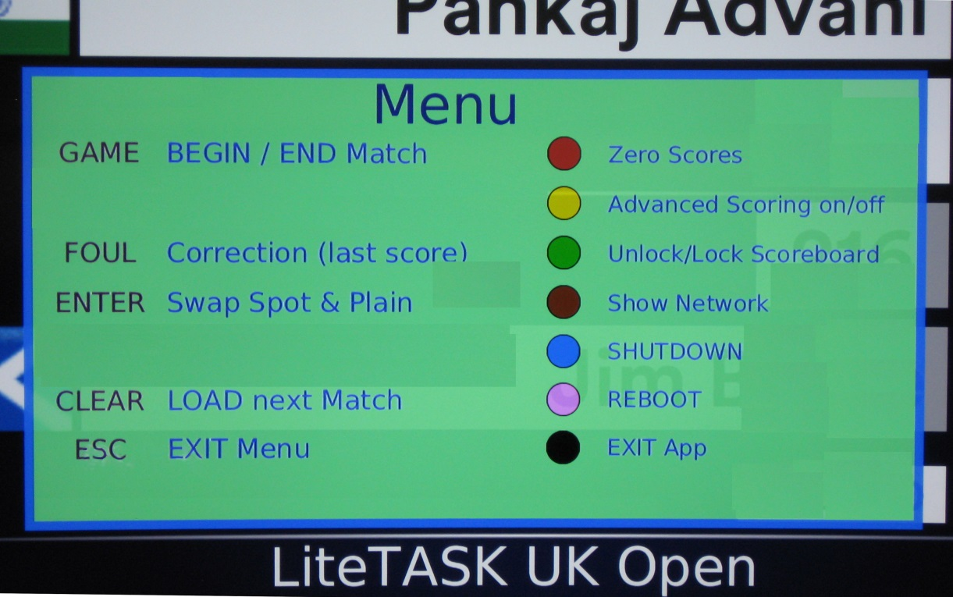

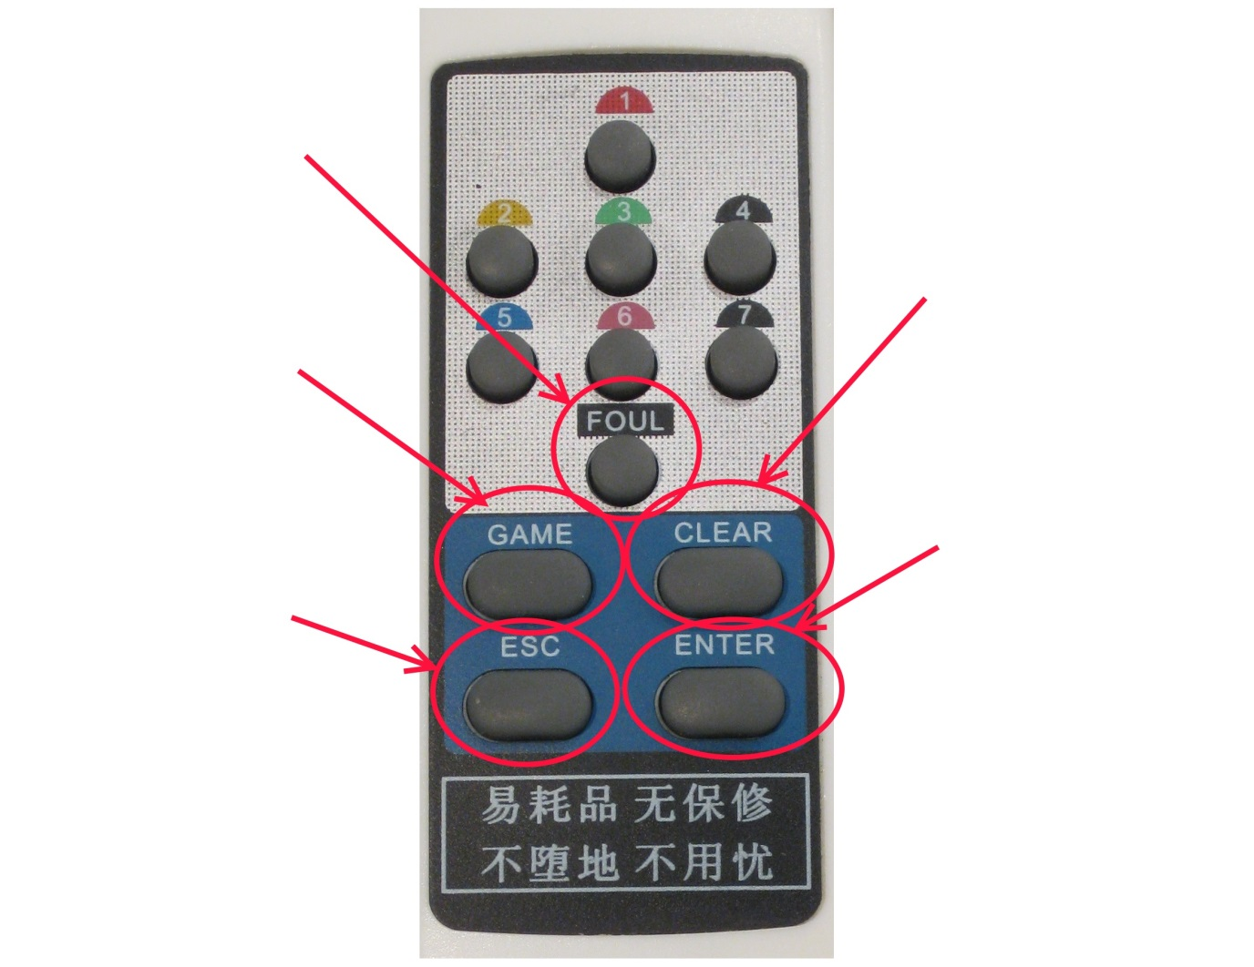

**LOAD next match**

**SWAP Plain and Spot**

**EXIT Menu mode**

**BEGIN or END Match**

**CORRECTION**(ie. Delete last score)

**Explanation of Menu Options**

|  |  |  |
| --- | --- | --- |
| **ESC** | | **Exit menu mode Note that it will automatically exit menu mode after 30 secs.** |
| **ENTER** | | **Swap spot and plain**  **After stringing, you may have to swap who is spot (always top).** |
| **GAME** | | **Begin / End Match**  **After a match has been loaded, BEGIN the match by pressing this button and the timer will start to count down. The timer will automatically END the match after time runs out, therefore you should NEVER have to END the match by pressing this.** |
| **CLEAR** | | **Reload next match**  **This will query the server for the next match scheduled for this scoreboard (and load it).** |
| **FOUL** | | **Correction**  **Use this to delete that last score entered. You can do this about ten shots back. However, it will not allow changes if the shot is ‘older’ than 4 mins.** |
|  | | |
| **1** | **C:\rpi devel\QB\Admin\Marketing\Manual\ball red.png** | **Zero Scores Reset the scores to zero. This will DISABLE the clock. Only do this if you are sure or are playing a ‘bounce’ match.** |
| **2** | **C:\rpi devel\QB\Admin\Marketing\Manual\ball yellow.png** | **Advanced Scoring on/off The layout of the balls buttons changes with advanced scoring. Advanced is more difficult than normal button layout.** |
| **3** | **C:\rpi devel\QB\Admin\Marketing\Manual\ball green.png** | **Unlock Scoreboard**  **Only do this if the scoreboard has locked after time has completed and you need to make a correction. This will DISABLE the clock.** |
| **4** | **C:\rpi devel\QB\Admin\Marketing\Manual\ball brown.png** | **Show debug info** |
| **5** | **C:\rpi devel\QB\Admin\Marketing\Manual\ball blue.png** | **Shutdown**  **Safely shut down the scoreboard.**  **ALWAYS do this before disconnecting or powering off. Never power it off without safely shutting down first in this way.** |
| **6** | **C:\rpi devel\QB\Admin\Marketing\Manual\ball pink.png** | **Reboot**  **Reboot the scoreboard. This is a safe operation, but may take 5 mins to complete.**  **If the system is ‘playing up’, then it is always worth rebooting.** |
| **7** | **C:\rpi devel\QB\Admin\Marketing\Manual\ball black.png** | **Exit App**  **Exit the scoreboard application.**  **Do NOT do this unless instructed.** |

Cheat Sheet

1. How can I do a ‘dummy run’ and have some practice ?

1. Start a game (ie. ESC then GAME buttons).
2. The timer should now appear on screen.
3. Enter scores, fouls, match pauses, switch plain & spot, etc. Have a good play and familiarise yourself with the functions.
4. However, **do NOT end the match** (ie. ESC then GAME buttons a second time).
5. Once you are happy, reload the same match by :- ESC then CLEAR buttons.

2. How do I START a game ?

Start a game by pressing the ESC then GAME buttons. The timer will now show on the screen, counting down.  
Note that you cannot enter any score until the match has been started.

3. How do I PAUSE the current match ?

When a player needs to go powder his/her nose, simply press the CLEAR button. The screen should now grey out and a red timer starts.   
When the player returns, press any button to RESUME the match.  
Note that the pause timer has recorded how long the pause was. The system will automatically add this time on to the end of the match when the main clock runs out.

4. How do I correct a score which I’ve just entered ?

Just press the ESC then FOUL buttons. The last score will be deleted.  
You can do this multiple times. The only restriction is that once a score has been in the system for over four minutes it cannot be changed.

5. How do I SAFELY shut down the system ?

The system is very sensitive to power supply outage. NEVER just power it off without ‘telling’ it to shutdown first. To do this just hit the ESC then 5 (blue) buttons to shut down the system first, then you can unplug the devices.

6. After stringing, how do I change Spot and Plain ?

Easy – ESC then ENTER buttons.  
The system will allow you to swap Spot & Plain after scores have been entered, for example if you forgot to switch them round at start of play. It will not however allow such a switch whilst a break is in progress.

7. If a player resigns, how to I end the match (early) ?

Occasionally it will be necessary to end the match early, such as a player resigning. To end the match just press ESC then GAME buttons. The screen will lock after this to prevent any accidental score changes.

8. The match has completed. How do I move on to the next match ?

Press ESC and then the CLEAR button. This will go to the server and get the next match scheduled for this scoreboard. If the current match has not completed, then this will simply RELOAD the current match (scores zeroed). This is handy if you want some practice - see (1).

9. After pressing a button nothing happens

It is worth remembering that the system reacts as you *release* a button, not whilst you are *holding it down*. Therefore press a button then take your finger off.

**ADVANCED Scoring**

**Note: This scoring setup (5 buttons) is more difficult than the normal button layout (2 buttons). It is perhaps better left for a Marker and not a Referee.**

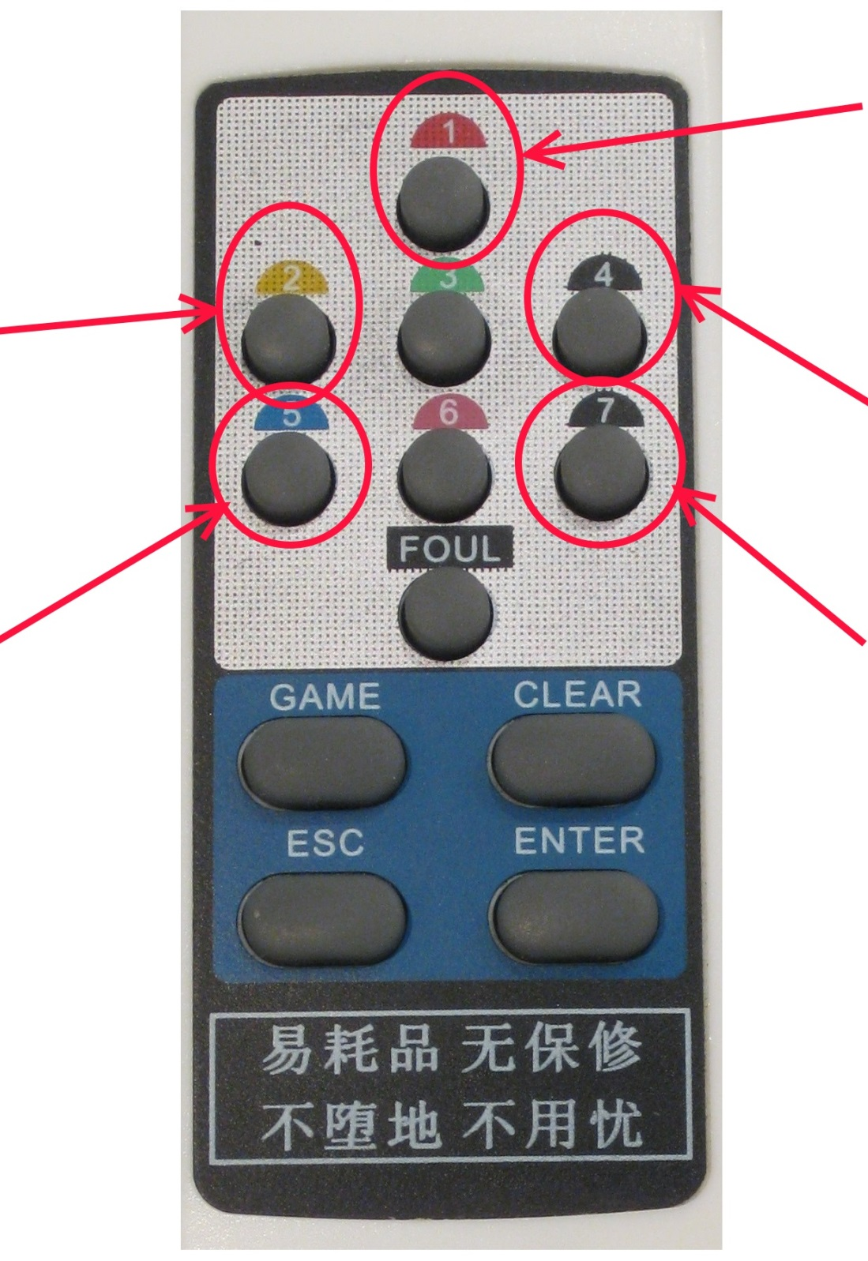

**CANNON**

**POT White**

**INOFF White**

**INOFF Red**

**POT Red**

Note that the following buttons are not used :- 3, 6, GAME.